Sentimental Analysis for Marketing

**Elaboration:**

**Sentiment analysis for marketing, also known as opinion mining, is a valuable tool for businesses to gauge public sentiment about their products, services, or brand. Here's an elaboration on how it works and its importance in marketing:**

***1. Definition of Sentiment Analysis:***

Sentiment analysis is the process of using natural language processing and machine learning techniques to determine the sentiment or emotion expressed in text data, such as social media posts, reviews, comments, and more.

***2.Importance in Marketing***:

Customer Insights:

Sentiment analysis allows businesses to understand how customers feel about their products or services. This insight can help in product development and refinement.

Reputation Management:

Monitoring online sentiment helps in managing a brand's reputation by identifying and addressing negative sentiment in a timely manner.

Competitor Analysis:

Businesses can analyze sentiment surrounding competitors to identify gaps in the market or areas where they can outperform rivals.

Marketing Campaigns:

It can inform marketing strategies by understanding what resonates with the target audience and what doesn't.

Customer Service:

Sentiment analysis can identify customer issues and complaints, allowing companies to provide better customer support.

***3. Techniques Used***:

Lexicon-Based Analysis:

This method uses predefined sentiment scores for words or phrases to determine sentiment in the text.

Machine Learning:

ML models are trained on labeled data to classify text into positive, negative, or neutral sentiments.

Aspect-Based Sentiment Analysis:

This approach dissects text to determine sentiment at a more granular level, focusing on specific aspects of a product or service.

***4. Challenges:***

Context Understanding:

It can be challenging to discern sarcasm, irony, or cultural nuances in text.

Data Volume:

Analyzing large volumes of data can be resource-intensive.

Accuracy: Achieving high accuracy in sentiment analysis, especially for complex, nuanced opinions, is an ongoing challenge.

***5. Tools and Platforms***:

Several tools and platforms offer sentiment analysis services, such as Google Cloud Natural Language API, IBM Watson, and more. These tools help automate the process.

***6. Real-World Examples***:

- Companies often track social media sentiment to adjust their marketing strategies.

- Online retailers use sentiment analysis to understand product reviews and improve product listings.

***7.Ethical Considerations:***

It's essential to respect privacy and handle customer data responsibly when conducting sentiment analysis.

In conclusion, sentiment analysis in marketing is a valuable technique that helps businesses gain insights into customer opinions, refine their strategies, and manage their reputation effectively. It plays a crucial role in today's data-driven marketing landscape.

**Block Diagram:**

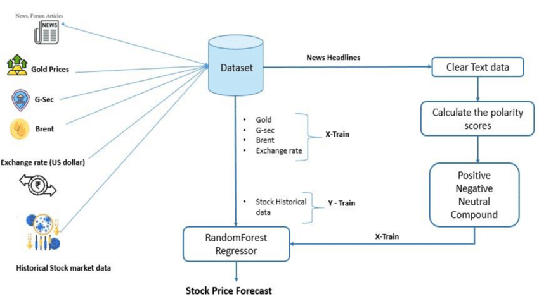

**Block Diagram for Sentiment Analysis System:**

A block diagram for a sentiment analysis system might consist of the following key components:

***1.Data Input Block:***

Represents the data sources, such as social media, review websites, or surveys.

***2.Preprocessing Block:***

This block includes processes like data cleaning, tokenization, and text normalization.

***3.Sentiment Analysis Block:***

Contains the sentiment analysis algorithm or model, which classifies the text data into positive, negative, or neutral sentiments.

***4.Positive Sentiment Action Block:***

Depicts actions taken in response to positive sentiment, such as marketing campaigns, promotions, or content creation.

***5.Negative Sentiment Action Block:***

Shows actions taken in response to negative sentiment, such as customer support, product improvement, or crisis management.

***6.Tracking and Reporting Block:***

Represents the components responsible for monitoring sentiment trends and generating reports.

***7.Data Output Block:***

This is where the analyzed data, reports, or insights are provided to the marketing team for decision-making.

Please note that you would typically use specialized software or drawing tools to create the actual flowchart and block diagram. These textual descriptions can serve as a guideline for creating visual representations of the sentiment analysis process in marketing.

**Flow Chart:**

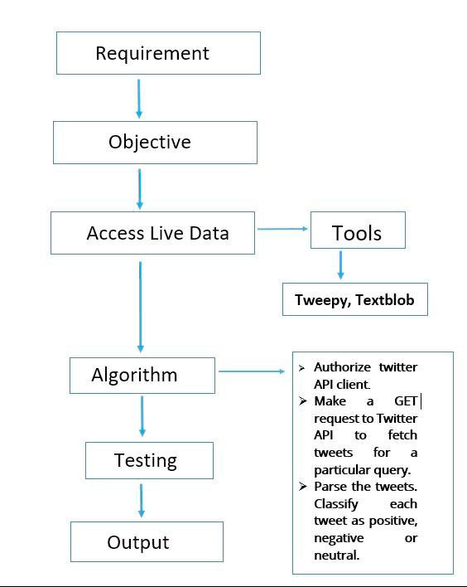

***Flowchart for Sentiment Analysis in Marketing:***

**1.Start:**

The process begins here.

**2.Data Collection:**

This block represents the collection of textual data from various sources like social media, customer reviews, or surveys.

**3. Data Preprocessing:**

Data preprocessing involves cleaning and preparing the text data. It might include tasks like removing stop words, special characters, and stemming.

**4.Sentiment Analysis:**

This is a decision block where the sentiment analysis process takes place. It branches into three paths:

Positive Sentiment:

If the sentiment is positive, the flow continues to a block for positive sentiment actions.

Negative Sentiment:

If the sentiment is negative, the flow continues to a block for negative sentiment actions.

Neutral Sentiment:

If the sentiment is neutral, the flow might proceed to a block for tracking or further analysis.

***5.Positive Sentiment Actions:***

This block includes actions that can be taken in response to positive sentiment, like promoting positive reviews, creating marketing content, or thanking customers.

***6.Negative Sentiment Actions:***

This block includes actions taken in response to negative sentiment, such as addressing customer complaints, improving products or services, or managing a PR crisis.

***7.Tracking and Reporting:***

This block represents the process of tracking sentiment trends over time and generating reports for marketing teams.

***8.End:***

The process concludes here.

**Enhanced Framework:**

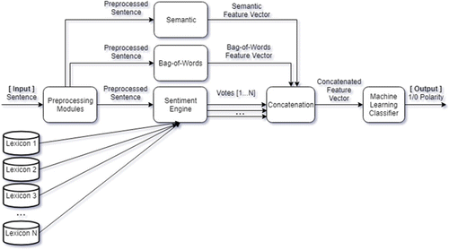

**Team Members:**

**I.JaharaAsmi**

**M.Muthulakshmi**

**M.Shajitha Barveen**

**M.Sathiya Jothi**

**K.Santhiya**

**JP College Of Engineering**